Question 1:

Define a “Book” structure that contains the following information:

● Title (a string of 100 characters)

● Author (a string of 50 characters)

● Year of publication (an integer)

Define a Library struct that contains:

● Library name (a string of 100 characters)

● An array of 5 Book structs (representing books in the library)

Write a program that:

● Initializes a Library struct named "City Library" and 2 books with sample data (book

titles, authors, and publication years).

● Prints the library's name and all book details (title, author, and year of publication).

● Use nested structs to access and print the information about each book in the library.

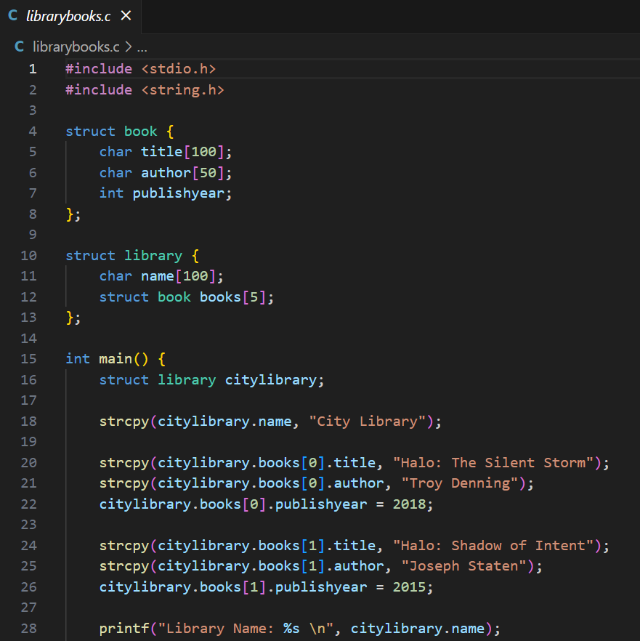

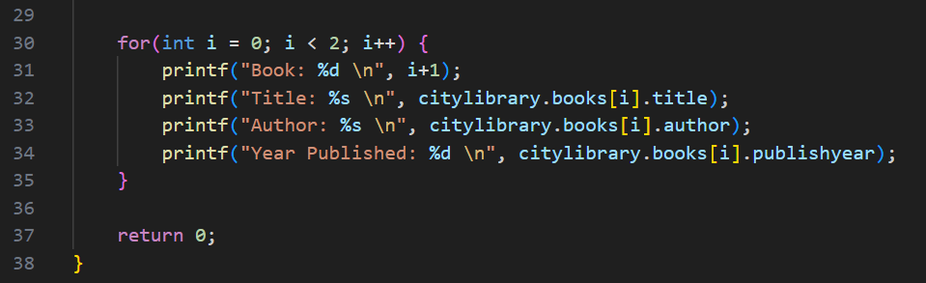

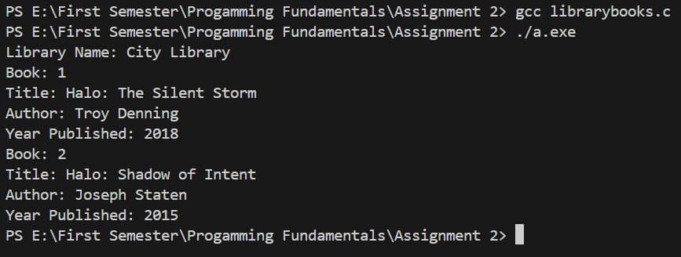

Question 2:

Define a “Student” structure with the following fields:

● Name (a string of 50 characters)

● Score (an integer)

Write a program that:

● Accepts a list of 5 student names (strings) and their corresponding scores (integers)

from the user.

**●** Store the data in an array of Student structs.

● Perform the following tasks:

○ Display the full name and score of each student.

○ Convert all student names to uppercase and print the updated names.

○ Find and print the name of the student with the highest score.

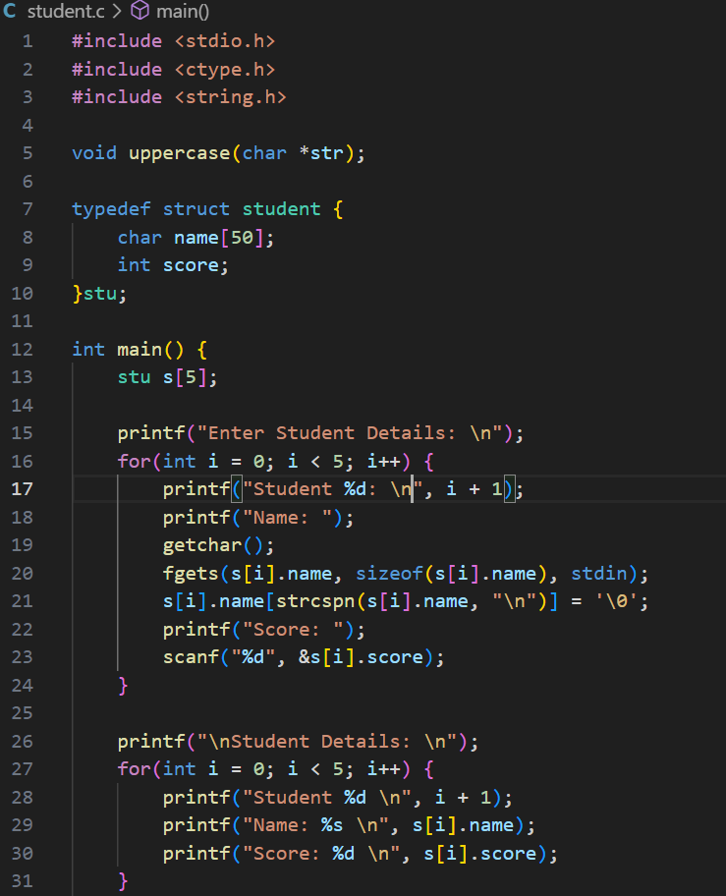

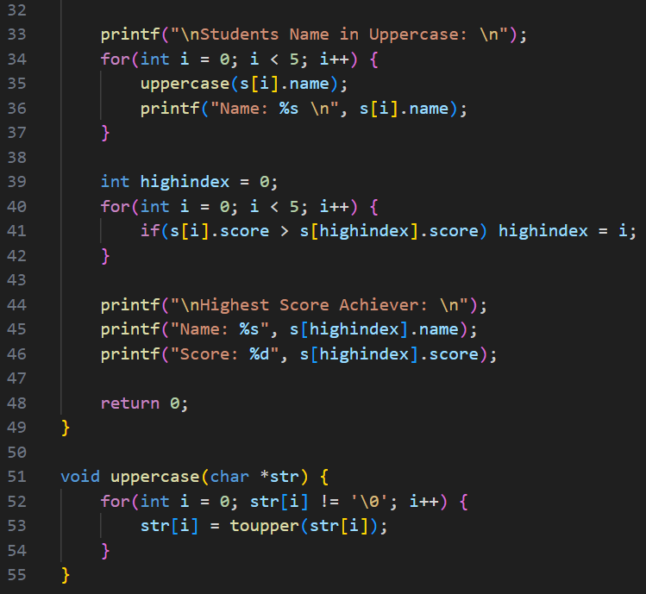

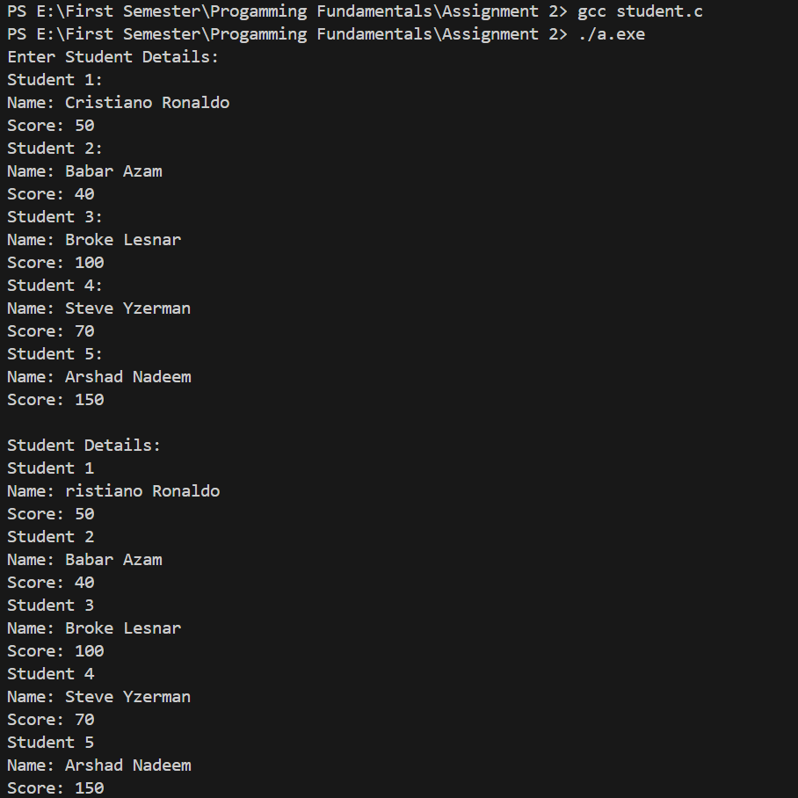

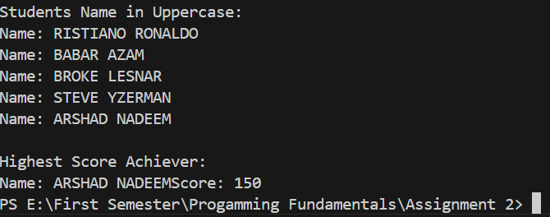

Question 3:

Define a Product struct that represents a product in an inventory system. The Product structure

should contain:

● Product ID (integer)

● Product name (string of 100 characters)

● Price (float)

● Quantity in stock (integer)

Write a program that:

**●** Creates an array of 3 Product structs and initializes them with product details such as

ID, name, price, and quantity.

● Alternatively, allow the user to input the details of 3 products.

● Calculate and print the total value of the inventory (i.e., the total price of all products in

stock).

● Find and print the most expensive product in the inventory.

